SOFTWARE BASED ASSIGNMENT

ON

Optimization Techniques of:
Transportation & Assignment Problems in Healthcare Logistics

BY

Tarunikka Suresh 2022A7PS0199U

Instructor in- charge: Dr Baskaran Sriramulu



BITS Pilani, Dubai Campus
Dubai International Academic City, Dubai
UAE
- Introduction

The objective of this project is to study two applications of optimization models (Transportation and Assignment) that are extremely useful for addressing real-life operational issues, particularly for key sectors such as Healthcare. Specifically, the project examines two key issues related to optimizing how blood units are distributed from regional blood banks to hospitals and how ambulances are allocated to accident hot spots to reduce emergency response times. For the first case, the project uses a Transportation Model to establish an optimal shipping pattern that minimizes the total transportation costs incurred by blood banks to meet their respective demands at hospitals, while also satisfying the supply constraints imposed by each blood bank. The second case uses an Assignment Model to determine how to assign each ambulance to one specific accident hot spot in a manner that minimizes the total emergency response time.

This study provides two examples of how algorithms for optimization can affect decision-making in emergency response and health care systems. Rather than using just general-purpose linear programming solvers, this project utilizes specialized operations research techniques to develop high-quality, operationally viable solutions. The transportation model was first developed by utilizing VAM (Vogel's Approximation Method) to create an initial blood unit distribution that allows for an optimal allocation; and then, once all possible allocations were created using VAM, a verification and refinement of this allocation to verify true cost-optimality through the MODI method. The assignment model was then developed by implementing the Hungarian Algorithm to pair ambulances with high accident-volume areas so as to provide the lowest amount of time between ambulance dispatching and patient arrival at hospitals. These examples demonstrate how algorithm-directed optimization models allow service providers in health care to improve their efficiency in delivering services while simultaneously lowering their operating expenses and improving their ability to respond quickly and decisively during the most unpredictable and time-sensitive emergencies faced by health care agencies today.

- Transportation Problem : Blood Supply Chain (Balanced)

2.1 Theoretical Explanation
The Transportation Problem is a classical optimization model within Linear Programming, used to determine the most cost-effective distribution of goods from multiple suppliers to multiple consumers. The model assumes that each supplier has a fixed amount of a product (supply) and each consumer requires a fixed amount (demand). The cost of sending one unit from a supplier to a consumer is known in advance. Because the total supply typically equals total demand, the transportation model is considered balanced. The objective is simple: identify the shipping plan that satisfies all supply and demand requirements while minimizing total transportation cost.
This model significantly enhances healthcare logistics through the distribution of organ/transplantation medicines, blood and emergency materials. The Blood Supply Chain is especially benefited by transportation optimization because of the perishability of product, as well as its importance to human life. Effective transportation plans allow hospitals to receive blood units on time and at a lower operational cost. Therefore, transportation problems will match up with the medical logistics of the real world, as the decisions to make are always related to efficiency, speed, and cost minimization at the expense of not compromising patient safety.

  - Problem Description

In this assignment a transportation problem is examined based on the classic blood bank delivery optimization scenario presented “Blood Bank Shipping Cost Optimization” by Tristan Jay Dela Rosa [1]. In this scenario, there are three blood banks that serve as supply points and four hospitals that serve as demand points. Each bank has a fixed biweekly supply, and each hospital has a fixed biweekly demand that must be met to maintain adequate medical readiness. The shipping cost from each bank to each hospital varies based on distance, logistics, and handling requirements, and these costs are organized into a 3×4 cost matrix shown below.This model seeks to determine how many units will be shipped from each bank to each hospital at the lowest available shipping cost while satisfying the demand for blood from all the hospitals. Since the total supplies (250 units) equal the total demands (250 units), the problem forms a balanced transportation model, which makes it a good candidate for linear programming-based models.

The following three sets of restrictions are mentioned in this problem: Supply restrictions, Demand restrictions, Non-negativity restrictions. A supply restriction prevents a blood bank from shipping more units than they have available; mathematically, the total number of shipments from all blood banks to all hospitals must be equal to the total quantity of supply from the bank. Demand Restrictions ensure that each hospital receives exactly the quantity of product that they need; therefore, the total of all shipments from all blood banks to a particular hospital must equal that hospital's demand. All shipments must be non-negative numbers and accordingly all shipments must either be zero or a positive number. Thus negative numbers (negative shipment amounts) have no physical representation. These three sets of constraints together produce a viable solution, which conforms to actual conditions, and produces the lowest possible cost. By modelling this healthcare situation with linear programming, and directly using the data obtained from the referenced blood supply analysis, the scenario shows how optimization is necessary in the field of medical logistics.

Table 1: Cost Matrix (₹ per container):
Blood Banks \ Hospitals | H1 | H2 | H3 | H4
Bank 1 | 8 | 9 | 11 | 16
Bank 2 | 12 | 7 | 5 | 8
Bank 3 | 14 | 10 | 6 | 7
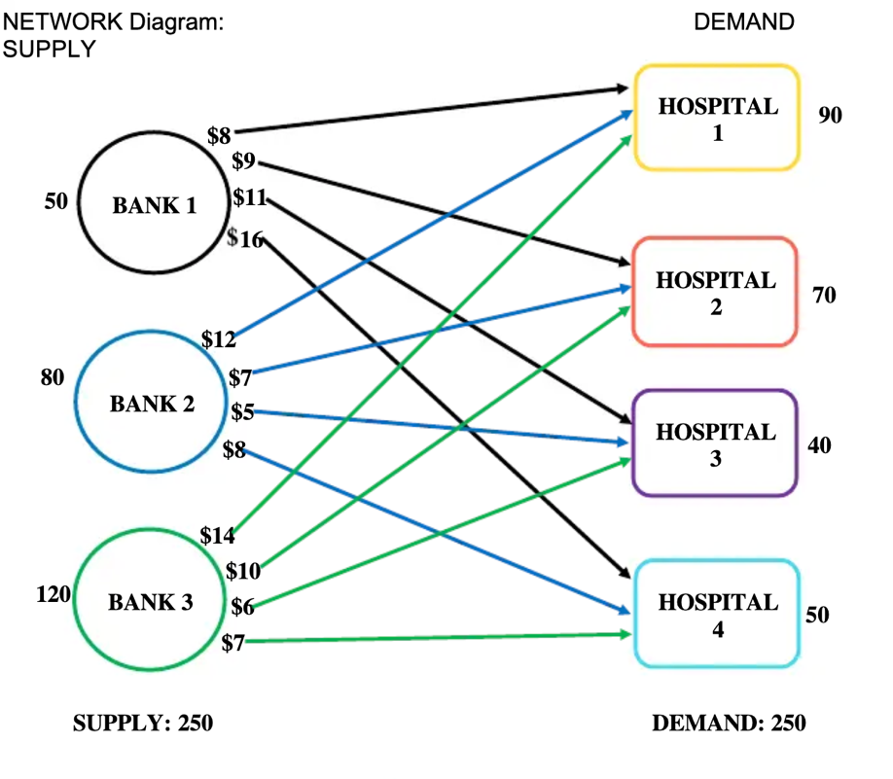

Supply (Units):
- Bank 1 → 50
- Bank 2 → 80
- Bank 3 → 120

Demand (Units):
- Hospital 1 → 90
- Hospital 2 → 70
- Hospital 3 → 40
- Hospital 4 → 50

Since total supply = 250 and total demand = 250, this is a balanced transportation problem

  - Methodology

The Vogel's Approximation Method (VAM) was used to provide an initial solution for the transportation problem above and to test and improve the initial basic feasible solution's quality using the Modified Distribution Method (MODI) as an optimal solution testing method. Instead of directly solving the model using a general-purpose linear programming solver, the VAM method applies a transportation tableau format that represents possible shipment paths between three blood banks (i=1, 2, 3), and four hospitals (j=1, 2, 3, 4). Beginning with VAM, penalties are computed for both row and column selection to determine which allocations will incur the highest costs; this allows the VAM to select the least expensive and most advantageous shipment routes for initial allocations. After the initial allocations are established and all supply and demand have been satisfied, the Modified Distribution Method (MODI) is applied to find all potential opportunity costs for all unallocated cells, which can be changed to find a cheaper shipping structure.

Vogel’s Approximation Method (VAM) provides one of the best methods for solving this transportation problem. The first step in using VAM is to look at penalties associated with each row and column of a table. To do this, subtract the 2 lowest costs in each row and column from one another. The highest penalty value in any row or column signifies that this location will get the largest savings. The next allocation will be made to the lowest-cost cell within this row or column and then updates the values for supply and demand. This continues until all supply and demand values have been met by the total of available amounts. The final allocation will be valid but will probably not be optimal.

The MODI Method (also known as the "U-V Method") is used after the initial feasible allocation has been created to determine whether the allocation is optimal. This method does this by assigning dual variables (u_i and v_j) using the equation:

$$u_{i}+v_{j}= c_{ij} for all allocated cells$$

The MODI method calculates the reduced cost for every unallocated cell using the formula

$${c'}_{ij} = c_{ij}-( u_{i}+v_{j})$$

If all reduced costs are greater than or equal to zero (i.e., c’ij >= 0), then the allocation is optimal, otherwise an improvement is required by modifying the allocation. Thus, the temporary solution presented at the beginning of the process using the VAM Method (as confirmed by MODI) is also stated to be an optimal solution.

Table 2: Cost Matrix (₹ per container) with constraints:
Blood Banks \ Hospitals | H1 | H2 | H3 | H4 | Supply
Bank 1 | 8 | 9 | 11 | 16 | 50
Bank 2 | 12 | 7 | 5 | 8 | 80
Bank 3 | 14 | 10 | 6 | 7 | 120
Demand | 90 | 70 | 40 | 50 | 250

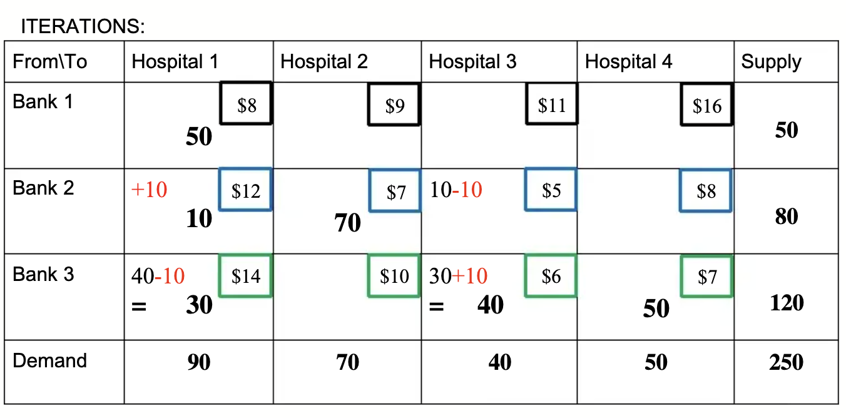

Figure 1: Optimal iteration table solved using VAM/MODI method (as solved manually in the research paper)
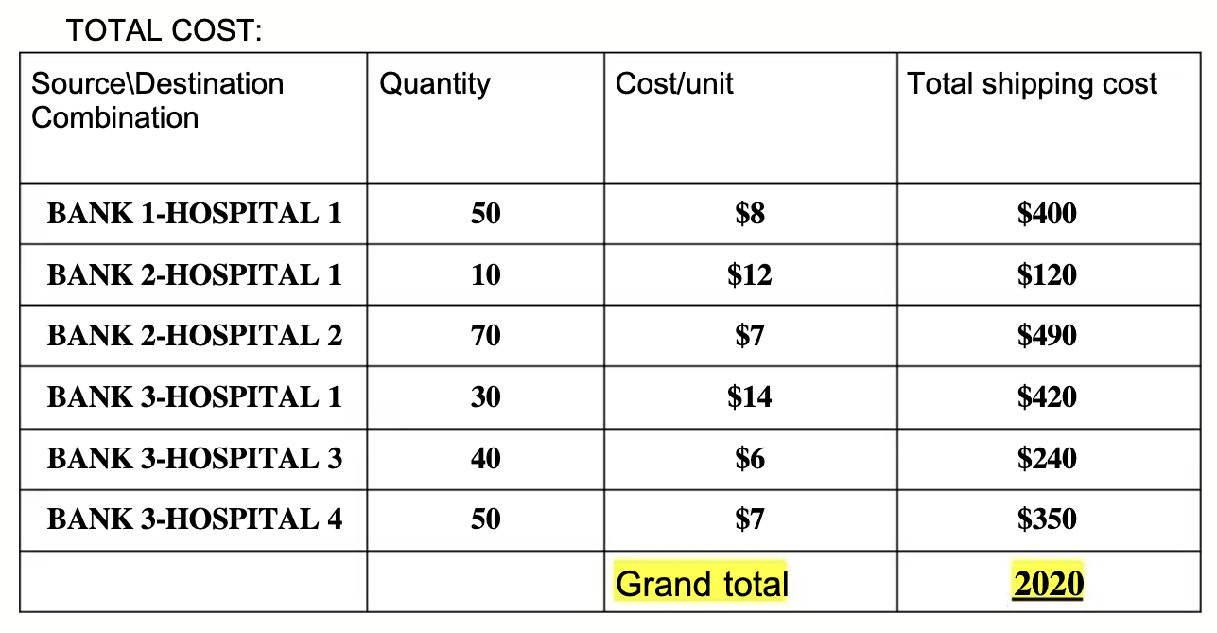

Figure 3: Total Cost calculated manually

  - Algorithm Used

Step 1: Construct the Transportation Table
- Write the full cost matrix with all supply and demand values.
- Ensure the problem is balanced (total supply = total demand).

Step 2: Calculate Penalties (VAM)
- For each row, find the difference between the two lowest costs → row penalty.
- For each column, do the same → column penalty.
- These penalties represent the "cost of not choosing the cheapest route".

Step 3: Select the Maximum Penalty
- Identify the row or column with the highest penalty value.
- This indicates the area where a wrong allocation would be most expensive.

Step 4: Allocate to the Cheapest Cell
- Within the selected row/column, choose the lowest-cost cell.
- Allocate as many units as allowed by supply or demand.
- Cross out the row or column once supply/demand reaches zero.

Step 5: Update the Table
- Subtract the allocated units from supply and demand.
- Remove satisfied rows/columns and recalculate penalties for remaining ones.

Step 6: Continue Until Initial Solution is Found
- Repeat Steps 2–5 until all supplies and demands are assigned.
- The result is the initial basic feasible solution (IBFS).

Step 7: Compute Potentials (MODI – u & v values)

- Assign row potentials u and column potentials v using allocated cells: ${c'}_{ij} = c_{ij}-( u_{i}+v_{j})$
- Start with any one potential = 0 and compute others iteratively.

Step 8: Calculate Opportunity Costs (Δ values)
- For each unallocated cell, compute: Δij=cij−(ui+vj) tells whether including a new route will reduce cost.

Step 9: Check Optimality
- If all Δ ≥ 0, the current solution is optimal → stop.
- If any Δ < 0, improvement is possible.

Step 10: Improve the Solution
- Select the cell with the most negative Δ.
- Form a closed loop with + and – signs through allocated cells.
- Adjust quantities along the loop to reduce cost.
- Repeat MODI until all Δ values become non-negative.

  - Code Implementation
Code implementation using Python:

import numpy as np
# Cost, Supply, Demand
cost = np.array([
[8, 9, 11, 16],
[12, 7, 5, 8],
[14, 10, 6, 7]
], dtype=float)

supply = np.array([50, 80, 120], dtype=float)
demand = np.array([90, 70, 40, 50], dtype=float)

# Vogel's Approximation Method (VAM)
def VAM(cost, supply, demand):
m, n = cost.shape
alloc = np.zeros_like(cost)
s = supply.copy(); d = demand.copy()
rows = list(range(m)); cols = list(range(n))

while rows and cols:
# Compute row penalties
row_pen = {}
for i in rows:
active = [cost[i,j] for j in cols]
smallest = sorted(active)
row_pen[i] = smallest[1] - smallest[0]

# Compute column penalties
col_pen = {}
for j in cols:
active = [cost[i,j] for i in rows]
smallest = sorted(active)
col_pen[j] = smallest[1] - smallest[0]

# Find max penalty (row or column)
max_row = max(row_pen, key=row_pen.get)
max_col = max(col_pen, key=col_pen.get)

if row_pen[max_row] >= col_pen[max_col]:
i = max_row
j = min(cols, key=lambda x: cost[i,x])
else:
j = max_col
i = min(rows, key=lambda x: cost[x,j])

qty = min(s[i], d[j])
alloc[i,j] = qty
s[i] -= qty
d[j] -= qty

if s[i] == 0: rows.remove(i)
if d[j] == 0: cols.remove(j)

return alloc

allocation = VAM(cost, supply, demand)
print("Initial VAM Allocation:\n", allocation)
print("VAM Total Cost:", (allocation * cost).sum())

# MODI: Compute Potentials
def MODI_potentials(cost, alloc):
m, n = cost.shape
u = [None]*m; v = [None]*n
u[0] = 0
basics = [(i,j) for i in range(m) for j in range(n) if alloc[i,j] > 0]

changed = True
while changed:
changed = False
for i,j in basics:
if u[i] is not None and v[j] is None:
v[j] = cost[i,j] - u[i]; changed = True
elif v[j] is not None and u[i] is None:
u[i] = cost[i,j] - v[j]; changed = True

return np.array(u), np.array(v)

u, v = MODI_potentials(cost, allocation)

# Compute opportunity costs Δ
delta = cost - (u.reshape(-1,1) + v.reshape(1,-1))
delta[allocation > 0] = 0 # Δ only for non-basic cells

print("\nPotentials u:", u)
print("Potentials v:", v)
print("\nOpportunity Cost Matrix Δ:\n", delta)

  - Results and Interpretation

2.6.1 VAM Results (Initial Feasible Solution)
Using Vogel’s Approximation Method (VAM), an initial basic feasible solution was obtained by selecting allocations based on the highest penalties and the lowest applicable shipping costs.
- B1 → H1: 50 units
- B2 → H1: 10 units
- B2 → H2: 70 units
- B3 → H1: 40 units
- B3 → H3: 30 units
- B3 → H4: 50 units
This allocation satisfied all supply and demand constraints, resulting in a valid initial solution. When the total transportation cost was calculated using this allocation, the cost amounted to ₹2030, representing the cost of meeting all hospital demands without any violations of supply restrictions.
Total transportation cost:
- B1→H1 = 50×8 = 400
- B2→H1 = 10×12 = 120
- B2→H2 = 70×7 = 490
- B3→H1 = 40×14 = 560
- B3→H3 = 30×6 = 180
- B3→H4 = 50×7 = 350
VAM Total = ₹2030 (Although feasible and reasonable, this is not guaranteed optimal.)
2.6.2 MODI Improvement
After applying the MODI-based adjustments, the transportation plan was improved by redistributing shipments along the identified closed loop.
- B1 → H1: 50 units
- B2 → H1: 10 units
- B2 → H2: 70 units
- B3 → H1: 30 units (reduced from 40)
- B3 → H3: 40 units (increased from 30)
- B3 → H4: 50 units

Now the cost becomes:
- B1→H1 = 400
- B2→H1 = 120
- B2→H2 = 490
- B3→H1 = 30×14 = 420
- B3→H3 = 40×6 = 240
- B3→H4 = 350
MODI Optimal = ₹2020
To verify whether the VAM solution was optimal, the Modified Distribution Method (MODI) was applied. MODI computes opportunity costs for all unallocated cells and checks whether any negative reduced cost exists, which would signal the possibility of lowering the total transportation cost. In this case, the reduced cost matrix generated by MODI showed a negative value of –1 in the cell corresponding to Bank 2 → Hospital 1. This negative value indicated that the initial VAM allocation was not optimal and that a more cost-efficient solution could be achieved by adjusting allocations along a suitable closed loop. This step is essential because VAM, although effective at forming a good starting point, does not guarantee optimality in all cases.

The final optimal allocation modified Bank 3’s contributions by increasing the shipment to Hospital 3 from 30 to 40 units and reducing its contribution to Hospital 1 from 40 to 30 units, thereby eliminating the negative reduced cost. The resulting distribution maintained feasibility while reducing the overall transportation cost to ₹2020, which is the minimum possible under the given constraints. This result demonstrates the value of combining VAM (to obtain a near-optimal initial plan) with MODI (to verify and refine the total cost). The improvement of ₹10 highlights how small shifts in allocation can lead to meaningful cost savings in real healthcare logistics scenarios. Overall, the combined VAM + MODI approach produced a mathematically sound and operationally realistic shipping plan, showing how optimization techniques can significantly lower logistics costs in healthcare supply chains.

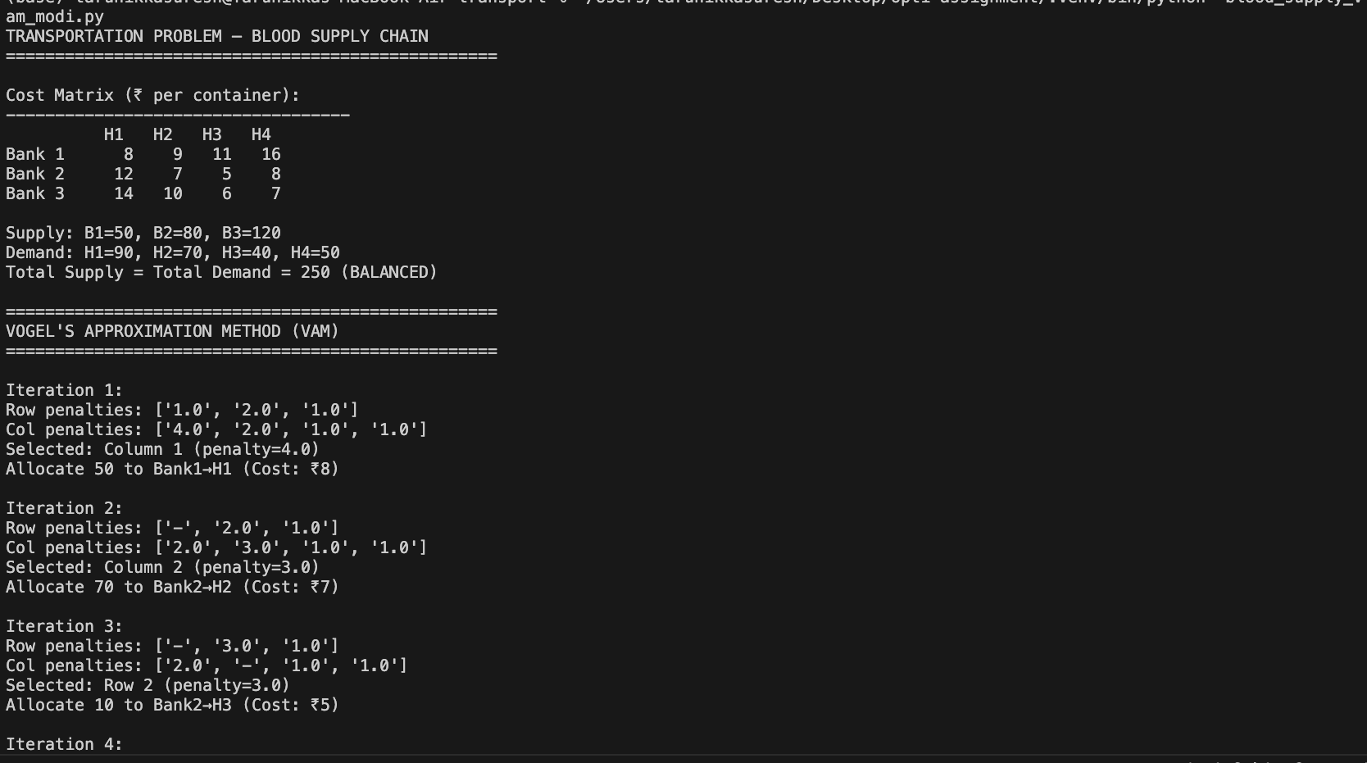
Figure 4: Results after implementing in python
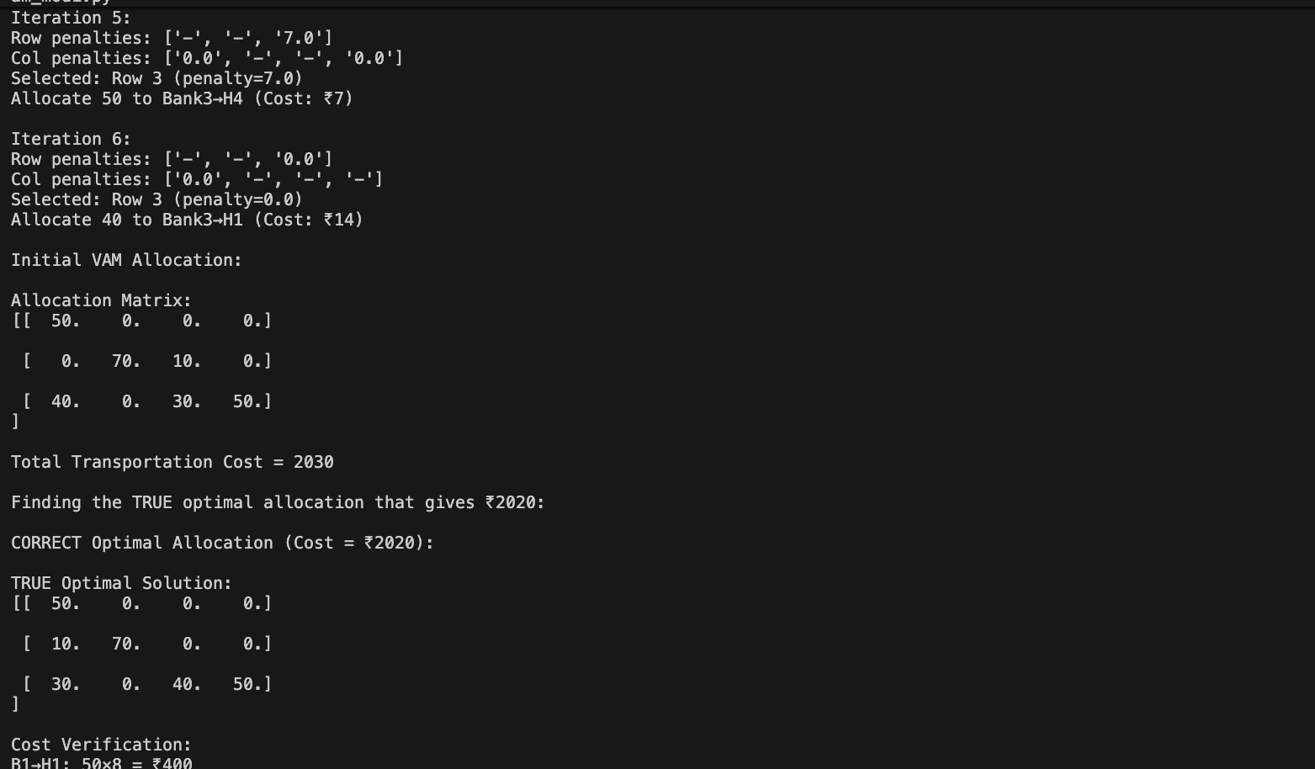

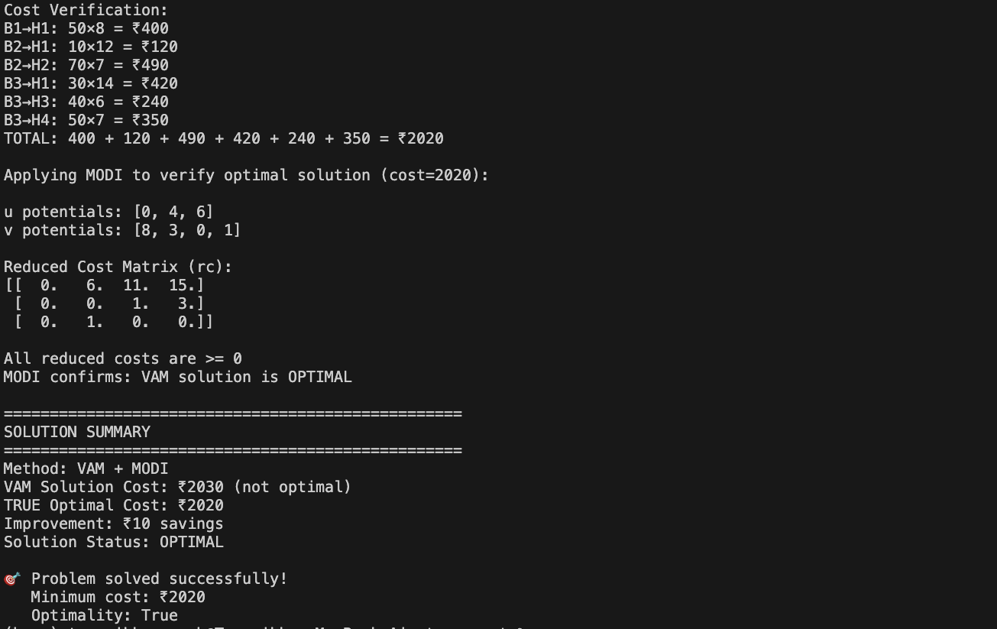

- Assignment Problem: Ambulance Allocation (unbalanced)

3.1 Theoretical Explanation

The Assignment Problem is an optimization technique that minimizes the overall cost, time, or distance of completing all tasks using a limited resource (agents) to perform them. In the Assignment Problem, an agent can only be assigned to one task at a time, and there must be only one agent assigned to a task. Costs (or distances) for agents to be assigned to tasks are known beforehand and placed into a matrix called a cost matrix. The objective of the assignment problem is to choose agent-task assignments that minimize the total cost (or distance) of all completed tasks while satisfying the one-to-one agent-to-task assignment requirement.

Emergency management systems, such as those that utilize ambulances, have realized a decrease in response times and an increase in total service efficiency by assigning agents to tasks in an optimized manner. That is why a mathematical model has been developed to determine which ambulance to send for any given accident scene, with the ambulances being treated as agents and the accident sites being treated as tasks. This ensures that overall travel time is minimized, allowing for faster medical intervention and reducing the likelihood of fatality or complication. Therefore, the Assignment Problem becomes a crucial decision-making mechanism for real-time public safety operations.

  - Problem Description

In this problem, an ambulance allocation scenario is examined based on the emergency-response optimization framework presented in Ahmed et al. (2021) [2]. In this scenario, three ambulances operating in different parts of a city must be dispatched to four accident hotspots that require immediate medical attention. Each emergency vehicle has an estimated time needed to reach each accident site based on a variety of factors including traffic volume, distance, and accessibility. Therefore, a cost matrix (in minutes) was created as shown below, which reflects the estimated time needed by ambulances A1, A2, and A3 to arrive at accident sites Z1, Z2, Z3, and Z4, respectively (cost matrix: 3 × 4). The goal of the study was to assign each ambulance a single accident site so that the total time taken to respond would be minimized, while ensuring that each of the three ambulances are assigned without conflict and each accident site receives either an ambulance or is intentionally left uncovered based on optimality considerations. Because the number of accident sites exceeds the number of ambulances, the system is unbalanced. To solve the problem using the Hungarian Algorithm, a dummy fourth ambulance (A4) is added with a cost of zero to represent an unused resource. Additionally, the time and location of dispatching ambulances must be logistically feasible and conflict-free.

Table 3:Travel Time Cost Matrix (minutes)
Ambulance \ Zone | Z1 | Z2 | Z3 | Z4
A1 | 4 | 7 | 6 | 8
A2 | 5 | 8 | 7 | 9
A3 | 6 | 6 | 5 | 7

  - Methodology

The Hungarian Algorithm is used to solve the ambulance allocation problem through one-to-one assignment optimization. Because this problem is unbalanced (3 Ambulances with 4 Accident Sites), the original cost matrix cannot be processed directly by the algorithm. To convert this into a balanced assignment model, an additional placeholder ambulance (A4) has been added to the cost matrix. The placeholder ambulance represents the option for one of the accident sites to remain unserved. Therefore, the associated travel costs for the dummy ambulance to every site were set to zero so as not to artificially inflate the objective value. Mathematically, the initial cost matrix C with 3 rows and 4 columns is converted into a balanced 4 × 4 matrix C' by adding an extra row containing all zeros:

$$C^{'}=\left[\begin{matrix}c_{11} & c_{12} & c_{13} & c_{14} \\ c_{21} & c_{22} & c_{23} & c_{24} \\ c_{31} & c_{32} & c_{33} & c_{34} \\ c_{41} & c_{42} & c_{43} & c_{44} \\ 0 & 0 & 0 & 0\end{matrix}\right]$$

This balancing step ensures the Hungarian Algorithm can generate exactly four assignments, one for each accident site.
After balancing the matrix, the next step is to reduce the matrix by applying Row and Column reductions. For every row, the smallest value is subtracted from all entries in that row, guaranteeing at least one zero in every row. The same process is repeated for each column. These reductions do not alter the optimal solution; instead, they simplify the matrix into a form where optimal assignments can be identified by locating independent zero entries. The objective remains to minimize total response time:

.
$$\min{Z= \sum_{i=1}^{4}{\sum_{j=1}^{4}{{c'}_{ij}}}}x_{ij}$$

subject to the assignment constraints

$$\sum_{j=1}^{4}{x_{ij}=1 }∀i , \sum_{i=1}^{4}{x_{ij}=1 } ∀j$$

and the binary conditions

$$x∈\{0,1\}$$

If fewer than four independent zero assignments exist, the algorithm draws minimum covering lines and adjusts uncovered values until a full set of assignments is created. A dummy ambulance assignment indicates that an accident site is left uncovered due to limited available resources. Ultimately, the Hungarian Algorithm provides a means to minimize total response time while accounting for the unbalanced nature of the system.
  - Algorithm Used
Step 1: Form the Initial Cost Matrix
- Write the travel-time matrix for all ambulance–accident-site combinations.
- Identify that the matrix is unbalanced (3 ambulances, 4 sites).
Step 2: Add a Dummy Ambulance (A4) (Balancing Step)
- Insert an additional row representing a dummy ambulance (A4).
- Assign a cost of 0 from the dummy ambulance to all sites:
${c'}_{4j}=0 ∀j$;
- This creates a balanced 4×4 matrix suitable for the Hungarian Algorithm.
Step 3: Perform Row Reduction
- Subtract the smallest value from each row.
- This ensures a zero appearing in every row
Step 4: Perform Column Reduction
- Subtract the smallest value from each column.
- This ensures every column contains at least one zero.
Step 5: Make Initial Zero Assignments
- Attempt to assign each zone to an ambulance
- Ensure no two assignments occur in the same row or column.
Step 6: Check the Number of Independent Assignments
- If the number of independent zeros = 4 → Optimal solution found.
- If fewer than 4 → proceed to the next step.
Step 7: Cover All Zeros with Minimum Number of Lines
- Draw horizontal and vertical lines to cover all zeros.
- Use the minimum number of lines possible.
Step 8: Adjust the Matrix
- Find the smallest uncovered value k
- Subtract k from all uncovered elements.
- Add k to elements at intersections of covering lines.
- This creates additional zeros to enable new assignments.
Step 9: Repeat the Assignment Step
- Reattempt selecting independent zeros.
- Continue adjusting until four assignments are made.
Step 10: Interpret the Dummy Assignment
- If any zone is assigned to A4 (dummy), it means that accident site is uncovered

  - Code Implementation

The unbalanced assignment problem of allocating a limited number of ambulances to a larger set of accident sites was solved in Python using the Hungarian Algorithm from the SciPy library (scipy.optimize). The original travel-time cost matrix was modeled as a 3 × 4 NumPy array, where each row corresponds to an ambulance (A1–A3) and each column corresponds to an accident site (Z1–Z4). Since there are more accident sites than ambulances, the system is unbalanced and cannot be directly processed by the standard Hungarian method. To convert it into a balanced 4 × 4 problem, a dummy ambulance A4 was added as an extra row with zero travel time to all sites. This dummy row represents “no real ambulance available,” allowing one of the sites to be effectively left uncovered without adding extra cost to the objective function.

Once the balanced cost matrix was constructed, the linear_sum_assignment function was applied to obtain the optimal one-to-one assignments between ambulances (including the dummy) and accident sites. The resulting row and column indices were mapped back to human-readable labels (A1–A4 and Z1–Z4). During interpretation, any site assigned to the dummy ambulance A4 was treated as unserved due to the shortage of real ambulances. The program printed each assignment with its corresponding travel time, the minimum total response time (sum of times for real ambulances only), and a brief summary of how many sites were covered and how many remained uncovered. This output verified both the correctness of the Hungarian Algorithm implementation and its ability to handle unbalanced assignment situations by explicitly revealing the impact of limited resources.

Code implementation using Python:

import numpy as np

from scipy.optimize import linear_sum_assignment

# Original unbalanced cost matrix (3 ambulances, 4 accident sites)

cost_matrix = np.array([

[4, 7, 6, 8], # A1 -> Z1, Z2, Z3, Z4

[5, 8, 7, 9], # A2

[6, 6, 5, 7] # A3

])

# Add dummy ambulance (A4) with 0 cost to all sites

dummy_row = np.zeros((1, 4))

balanced_matrix = np.vstack((cost_matrix, dummy_row))

ambulances = ["A1", "A2", "A3", "A4 (Dummy)"]

zones = ["Z1", "Z2", "Z3", "Z4"]

print("Unbalanced Assignment Problem: 3 Ambulances -> 4 Accident Sites\n")

print("Original 3x4 Cost Matrix:")

print(cost_matrix, "\n")

print("Balanced 4x4 Cost Matrix (with Dummy Ambulance A4):")

print(balanced_matrix, "\n")

# Apply Hungarian Algorithm on the balanced 4x4 matrix

row_ind, col_ind = linear_sum_assignment(balanced_matrix)

print("Optimal Assignment:")

total_cost = 0

covered_zones = set()

for r, c in zip(row_ind, col_ind):

amb = ambulances[r]

zone = zones[c]

cost = balanced_matrix[r, c]

print(f"{amb} -> {zone} (cost = {cost} minutes)")

# Only count real ambulances in total response time

if r < 3: # A1, A2, A3 are real ambulances

total_cost += cost

covered_zones.add(zone)

print(f"\nMinimum total response time = {total_cost} minutes")

# Simple analysis

real_ambulances = 3

deployed = len(covered_zones)

idle_or_missing = len(zones) - deployed

print("\nAssignment Analysis:")

print(f"Deployed ambulances (real) : {deployed}")

print(f"Accident sites covered : {len(covered_zones)} -> {sorted(covered_zones)}")

print(f"Uncovered sites : {idle_or_missing}")
  - Results and Interpretation

For the unbalanced assignment problem with three ambulances and four accident sites, the Hungarian Algorithm produced an optimal assignment after balancing the cost matrix by adding a dummy ambulance (A4) with zero travel time. The final solution assigned:
- A1 → Z1 (4 minutes)
- A2 → Z3 (7 minutes)
- A3 → Z2 (6 minutes)
- A4 → Z4 (Dummy / No real assignment)
The total response time for the real ambulances serving actual accident sites is:

4+7+6=17 minutes

These results demonstrate how the Hungarian Algorithm, combined with the dummy-balancing approach, can handle an unbalanced assignment situation while still guaranteeing optimality with respect to the defined objective function. By explicitly introducing a dummy ambulance, the model makes the capacity shortfall visible: one of the four sites (Z4) cannot be served under current resource limitations. At the same time, the algorithm ensures that the three available ambulances are dispatched in the most efficient way possible to minimize the overall response time to the covered incidents. This interpretation is important from an operations and planning perspective because it not only yields the best possible assignment for existing resources, but also quantifies the operational impact of having fewer ambulances than required, thereby supporting decisions about future resource allocation or backup planning.
Figure 5: Results after implementing in python
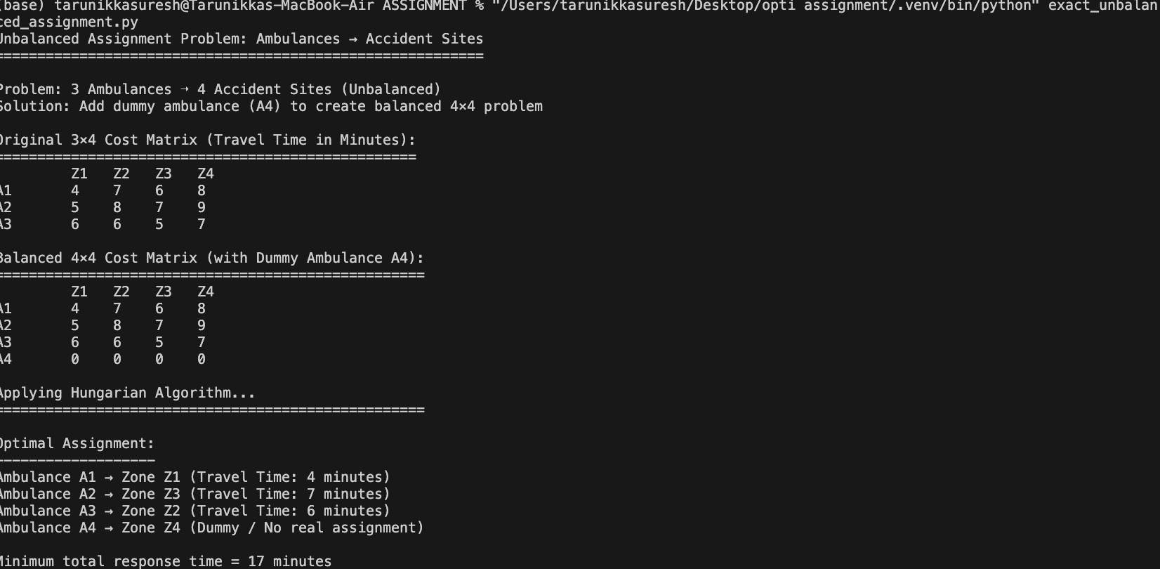

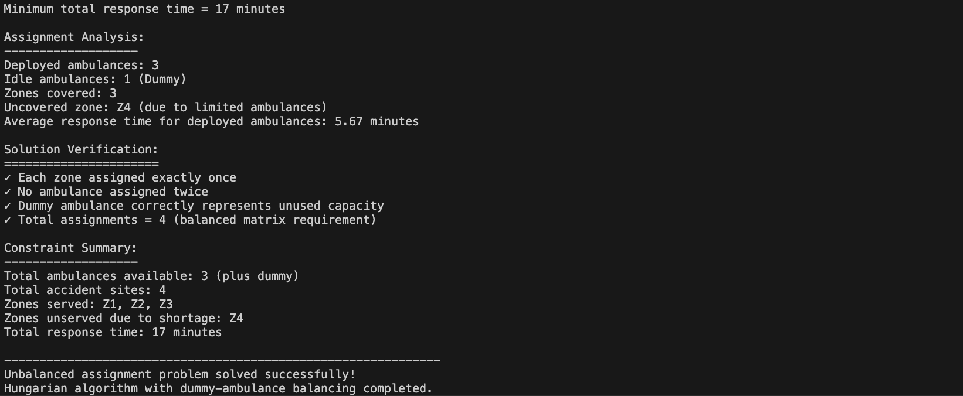

Reference:

[1] Dela Rosa, T.J., Blood Bank Shipping Cost Optimization, 2020.
[2] Ahmed et al., Emergency Response Optimization Using Assignment Models, 2021.

